No. of Pages  A | 4
No. of Questions | 4

Department of Computer Science and Engineering
MIDTERM EXAMINATION SPRING 2016

CSE421: Computer Network
Total Marks: 45 Time Allowed: 55 minutes
- Answer ALL THREE (3) questions
- Figure in bracket [] next to each question indicates marks for that question

Question 1
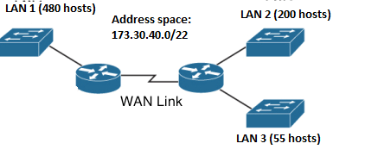
Figure no. 1

- Suppose a company is given a block 173.30.40.0/22. But you need three more sub networks for your organization and one more for the WAN Link as shown in figure no. 1. Show how you can have 4 more subnets out of the original network address as per host requirements. Do not forget to show basic calculations. [8 marks]

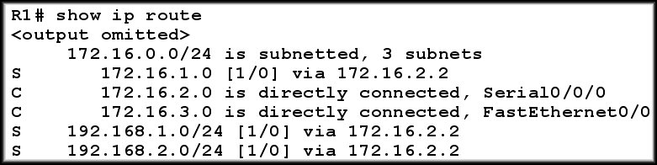
Figure no. 2
b) Refer to the above output shown in figure no. 2, A packet with the destination IP address of 192.168.2.25/24 is received by the router. How will the router find the exit interface to send the packet? Can we increase the efficiency of the router lookup process? [5 marks]

Question 2
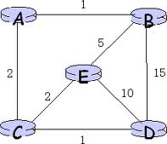
Node A Table
 | A | B | C | D | E
A | 0 | 1 | 2 | ∞ | ∞
Node B Table
 | A | B | C | D | E
B | 1 | 0 | 16 | 15 | 5
Node E Table
 | A | B | C | D | E
E | ∞ | 5 | 2 | 3 | 0

Figure no. 3

- For the above figure no. 3, the tables represent the routing table of Router A,B and E currently. Router B receives updates from A and E routers. All routers are running Distance Vector algorithm. What will be the status of the routing table of Router B be after receiving the updates? (Use Dx(y) = min{c(x,y) + Dy(y), c(x,z) + Dz(y)} for explaining your answer) [7 marks]

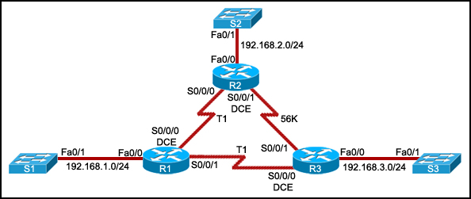
Figure no. 4

- Refer to figure no. 4 above, router R2 uses RIPv2 routing protocol? To send packets to R3 it uses the 56kbps line even though it is a slower than the combined link of two T1 links. Explain. [5 marks]


Figure no. 5

- The Gateway Router in the above figure no. 5 is running RIP routing protocol. The network administrator does not want to send any RIP updates via s0/0. What can be done? [3 marks]

Question 3

Table no. 1: R2 link state database
R2 Link states:
Connected to neighbor R1 on network 192.168.4.0/24, cost 40
Connected to neighbor R7 on network 202.212.0.0/24, cost 60
Has a network on 40.10.1.0/8, cost 2
R1 Link states:
Connected to neighbor R2 on network 192.168.4.0/24, cost 40
Connected to neighbor R3 on network 10.10.1.0/8, cost 50
Connected to neighbor R4 on network 172.16.2.0/16, cost 40
Has a loopback interface with address 122.20.20.10
Has a network on 85.10.2.0/8, cost 2
R3 Link states:
Connected to neighbor R1 on network 10.10.1.0/8, cost 50
Has a network on 20.20.1.0/8, cost 2

R4 Link states: Router-id: 15.15.14.6
Connected to neighbor R1 on network 172.16.2.0/16, cost 40
Connected to neighbors R6 and R7 on network 192.168.9.0/24, cost 20
Has a network on 40.40.40.0/8, cost 2

R6 Link states:
Connected to neighbors R4 and R7 on network 192.168.9.0/24, cost 20
Connected to neighbor R7 on network 192.168.5.0/24, cost 10
Has a network on 25.25.20.0/8, cost 2

R7 Link states:
Connected to neighbor R2 on network 202.212.0.0/24, cost 60
Connected to neighbors R6 and R4 on network 192.168.9.0/24, cost 20
Has a loopback interface with address 23.34.64.7
Has a loopback interface with address 180.48.48.8
Has a network on 30.10.1.0/8, cost 2

- From table no. 1 construct the network and determine the router-ids for R1, R2, R3, R4, R6, R7. Is there a need for DR and BDR? If so, which of these routers will be DR and BDR? [3+3+2+2 marks]
- Why do you think loopback interface has priority over active physical interface during router ID selection process? [3 marks]
- Link State Algorithm has faster convergence, why? [2 marks]

THE END

